Asif subhan, Ricky Sanders, Evan Simmons, Meng Qi

asubhan@uncc.edu

Abstract

This document will provide the necessary information and instruction to install the code on a webs server or XAMPP

installation guide for source code

Instructions to X Note Plus source code

Contents

Get the Source Code 2

UNZIP the Source Code 2

Locate the Database Folder 2

Locate Core Files 2

Installing XAMPP 2

How to Install XAMPP 2

Locate HDDOCS Folder 3

Setup Database 3

Create Database 3

Import Tables 3

Change Core 4

Locate Admin user 4

# Get the Source Code

Get the source code either from the BitBucket, github or DVD. The source code is compressed in a ZIP folder. In the ZIP folder you will find all the required files to run the code.

## UNZIP the Source Code

UNZIP the source code into a folder named xnoteplus or folder of your choice.

## Locate the Database Folder

Inside the unzipped folder you will find a folder named DatabaseFiles. Remember that folder we will need it in few steps

## Locate Core Files

There are two files once named “core.inc.php” and another named “admin.core.inc.php”. We are going to need to change the database name based on what database named you choose. Or in some cases you have to use a prefix name

* ../xnoteplus/core.inc.php
* ../xnoteplus/admin/admin.core.inc.php

# Installing XAMPP

If you already have XAMPP install or know how to install XAMPP, Skip this step

## How to Install XAMPP

* Go to <https://www.apachefriends.org/download.html>
* Download the latest version, click to install
* Install Apache , MySQL, FileZilla, Perl, phpMyAdmin

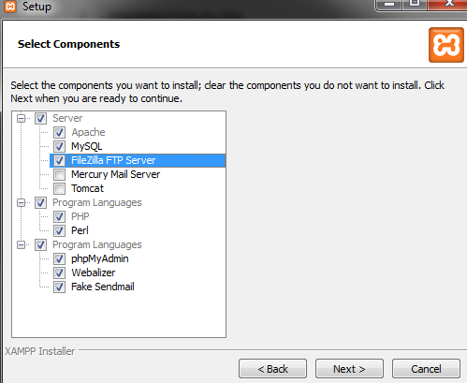

* After installing go to <http://localhost> and make sure you see the flowing page

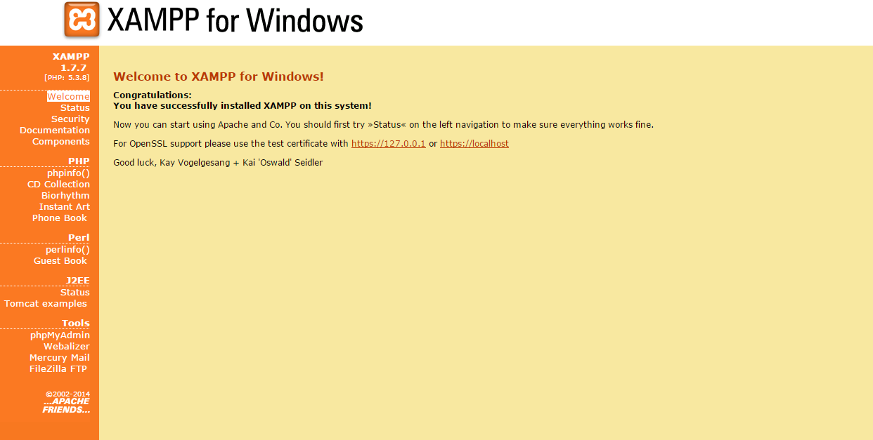

## Locate HDDOCS Folder

* Go to where XAMPP you install and locate XAMPP folder
  + Most likely in C Drive. C:/ C:\xampp\
* Go to HDDOCS folder
  + C:\xampp\htdocs
* Copy the Final Template folder from the unzipped folder to HDDOCS

# Setup Database

At this point you should have XAMPP working. In this section we will make a database, and import tables to that database

## Create Database

* Go to <http://localhost/phpmyadmin/>
* Create a Database named ‘a_database’ or any other named you prefer
  + If you choose another name, you must change the database name in the core files

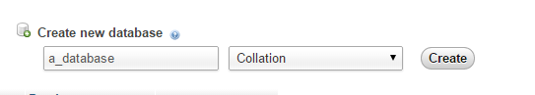

## Import Tables

* Select a_database on left
* Click on Import to import the database
* Choose “a_database” file from Database_files and hit GO
* You should have all the necessary tables in the database

## Change Core

* If you used different database name (other than “a_database”) skip this step
* Open both core files
  + Core.inc.php
  + Admin.core.inc.php
* Locate function named DatabaseName()
  + Change the name of database from “a_database” to your database name

## Locate Admin user

* Go to phpMyAdmin
* Click on table users
  + You can see all the users their
* Admin user
  + UserName: asubhan
  + Password : password
* Admin page
  + You can look up all the user by going to the admin page

